Taylor Malott

Honors International Capstone

Professor Amy Hirsch

Professor Brian Kyser

8 May 2017

Architecture Reflects Theology

A Comparison of The Modern Megachurch and The Gothic Cathedral

Paul Goldberger, writing for the New York Times, described the differences between two mega-sized church types thus: “The Gothic cathedral was designed to inspire awe and thoughts of transcendence. Megachurches celebrate comfort, ease and the very idea of contemporary suburban life.” While Gothic cathedrals stand out as architectural wonders, and are studied frequently as a matter of course, megachurches do not hold this prestigious status. But the architecture of megachurches is just as informed by religious thought and intentions as that of Gothic cathedrals. This project will be a comparative analysis of the architecture of these two types of churches—and the religious thought process behind them. These two types of churches will be defined in terms of architectural elements and the underlying theological objectives, a visual summary of the architecture will be given, and finally, both types will be compared to answer the following question: What do the differences between the functional objectives of Gothic cathedral and modern American “megachurch” architecture reveal about the social context of each church?

Gothic architecture is characterized by visual elements such as pointed arches (as opposed to the rounded arches of the Romanesque period), ribbed vaults, and rose-windows. Pointed arches were developed to create stronger, lighter arches that directed more of their weight downwards, rather than outwards, allowing the supporting walls to be thinner than before (Chapuis). The ribbed vault was constructed using the pointed arch profile, extended horizontally. Where two vaults intersected, crisscross “ribs” were placed (see Figure 1). These ribs reinforced the vault, allowing lighter materials to be used in the space in between, which also allowed for “daintier” walls. Both of these architectural developments allowed cathedrals to be taller than before and to feature more stained-glass windows—such as the rose-window (Chapuis). The rose-window (Figure 2) usually included God the Father, Jesus Christ, or the virgin Mary at the center “surrounded by the cosmos” (Chapuis). These beautiful windows filtered white light into many colors, evoking the “heavenly Jerusalem” of the book of Revelation (Chapuis).

Figure 1: Vellut Basilique de Saint-Denis @ Saint-Denis 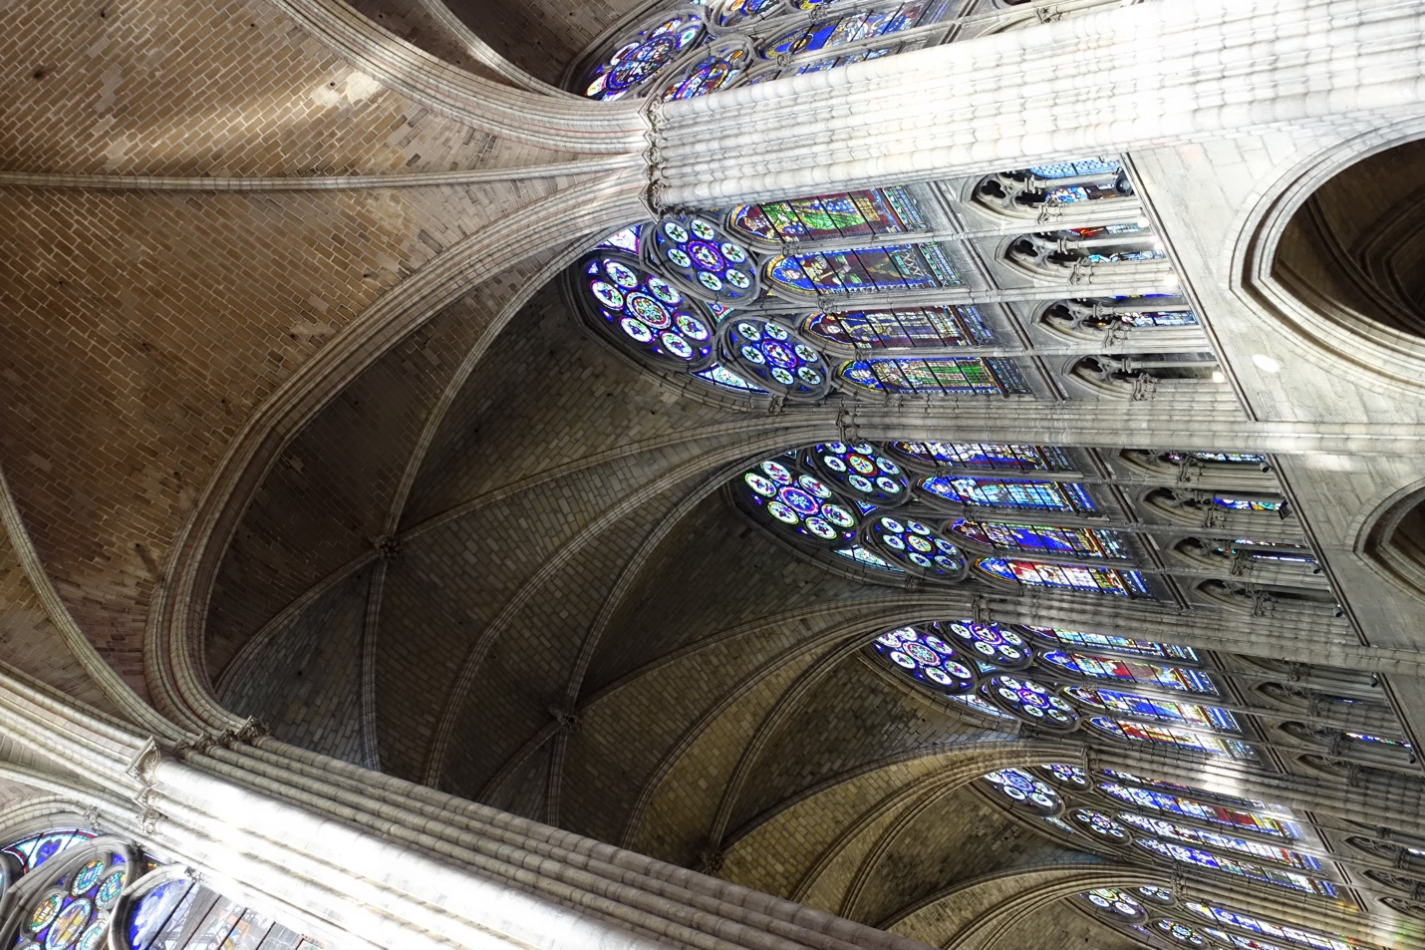

Figure 2: TTaylor St Denis North a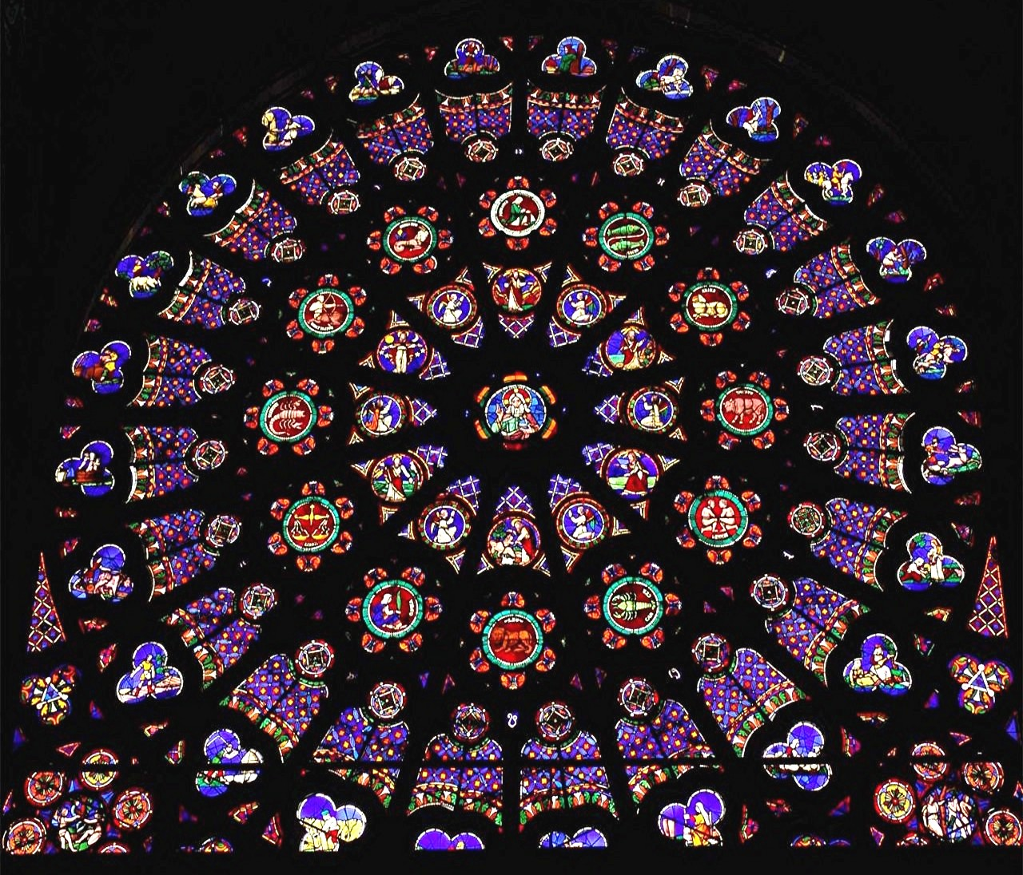

This heavenly sense was a key component in the design of Gothic cathedrals. They were designed to be a sort of memorial to God, a place where people could have a sense of awe as if they were in God’s presence (Schlager and Lauer). Suger, abbot of Saint Denis in France, wrote of the “memorable construction of [the Basilica of Saint Denis], so that by this [building] thanks might be given to Almighty God by us as well as our successors” (XXIV). Suger oversaw the construction of the Basilica between 1140 and 1144 AD, which marked a definite beginning for Gothic architecture in cathedrals (Chapuis). He had an “infatuation” with light, seeing it as the embodiment of the divinity of God (Dupre 32). The “manipulation of light in large expanses of stained glass…determined the translucence, pointed arches, and soaring interiors” of the Gothic cathedrals that were constructed after Suger’s Basilica (Dupre 32). This heavenly light is not the only awe-inspiring aspect. Those soaring interiors were created with many vertical lines, as demonstrated by the columns in Figure 1. Chapuis writes that the “typical elevation…draws the gaze to the highest point in the vault [of the cathedral], in an irresistible upward pull symbolic of the Christian hope…for a heavenly realm.” Indeed, the vertical lines and open space are like open highways—the eye cannot resist racing along the lines to where they meet at the pinnacle of the vault, much like the photographer’s lens in Figure 1. While this upward pull is symbolic of heaven, the large volume of the space creates a sense of smallness—and for many, a sense of “the majesty and power of God” which church leaders desired to foster (Schlager and Lauer).

While the space and light were meant to communicate a sense of awe, other symbols were meant to communicate the narrative of the Bible to those who couldn’t read. Abbot Suger reproduces the inscription on the doors of Saint-Denis:

Whoever thou art, if thou seekest to extol the glory of these doors,

Marvel not at the gold and the expense but at the craftsmanship of the work.

Bright is the noble work; but, being nobly bright, *the work*

*Should brighten the minds*, so that they may travel, through the true lights,

To the True Light where Christ is the true door.

In what manner it be inherent in this world the golden door defines:

The *dull mind rises to truth through that which is material*

And, in seeing this light, is resurrected from its former submersion. (XXVII emphasis added)

The symbolism on these doors served to communicate truths of Christianity to the illiterate in a way that they could read—images. While this inscription is referring to the doors of Saint-Denis, the same purpose is inherent in the pictorial aspect of stained-glass windows. The windows depicted narratives from the Bible, and were “central to the perception of the cathedral as a compendium of the Christian faith” (Chapuis). As mentioned above, the rose-window included different characters, with God the Father, God the Son, or the virgin Mary at the center—communicating without words the importance of these individuals.

Thus, the architecture of the Gothic cathedral exhibits the design purposes of inspiring “awe and thoughts of transcendence” (Goldberger). Like the modern Gothic cathedral, American megachurches are large churches. But the visual similarity stops short there. The architectural elements of and lack of symbolism in these churches reveals an altogether different functional objective from that of the Gothic cathedral.

The term “megachurch” must be defined holistically, not just in terms of architecture. This is a difficult thing to do, as the American “megachurch” is a very modern phenomenon—most megachurches were founded after 1955, and did not see the “explosive growth” characteristic of such churches until the 1980s (Thumma). Scott Thumma, PhD, a professor at Hartford Seminary’s Religious Research Institute, has performed extensive research into the megachurch phenomenon, and his 1996 dissertation “The Kingdom, the Power, and the Glory: Megachurches in Modern American Society” is a valuable resource for understanding this religious phenomenon. While various megachurches are distinct and variable in their expressions of the megachurch characteristics Thumma observes, they “have too much in common not to be seen as a distinct social and religious reality” (Thumma). These general characteristics that Thumma has observed form his definition of the term “megachurch,” and will form the definition of the term for this project.

Apart from being a recent phenomenon, megachurches have a large weekly attendance—Thumma sets the threshold for this at 2,000 persons. These churches also value denominational ties less than other churches. Thumma also writes that half of American megachurches are nondenominational, and the rest “downplay” their affiliation by removing references to it from their names (Thumma). According to Thumma, these churches have an “appealing identity as a congregation” (Thumma). Thus, they do not see a need to emphasize their denominational ties as a draw for visitors.

These churches do not have this “appealing identity” by accident. Another characteristic of megachurches is that they emphasize their ministry as “more vital” from what other churches are doing, and “better than ‘ordinary’ Christianity” (Thumma). These churches want to seem *extraordinary*, in order to draw people in. Dr. Thumma further categorizes the megachurch phenomenon into three subcategories, or approaches to achieving “extraordinary” status. The first category takes the “nontraditional” approach. This approach seeks to “remake the traditions so they are…relevant to the modern person who [has] been turned off by traditional religion” (Thumma).  These churches are trying to attract “seekers” and the “unchurched” (Thumma). The second category takes the “conventional” approach. This approach is generally taken by older megachurches, and is characterized by a “retention of the images of traditional Christianity”—but this tradition is supposed to be bigger and better (Thumma). Conventional megachurches are still trying to attract a modern audience, but one that has a familiarity for traditional forms. These churches want to seem more exciting than a completely traditional church—still reaching for that “appealing identity—while retaining an aroma of authenticity (Thumma). Their inclusion of traditional forms—such as recognizable architecture—serves that purpose. Dr. Thumma’s third subcategory of megachurches takes the “composite” approach to reach an appealing atmosphere. This is a hybrid of the nontraditional and conventional approaches—composite megachurches still retain some traditional aspects, but not enough to fit into the conventional category. These churches generally use a modern building and worship service format, while keeping some of the traditional symbolism—like overlaying a modern, utilitarian building with a traditional facade.

The category of interest in this paper is the nontraditional megachurch, and specifically the underlying thought process (whether religious or simply practical) that shapes the architecture of the nontraditional megachurch. From this point on, the term “megachurch” will refer to the nontraditional category of such churches. The megachurch’s efforts to reach those outside of the church focuses not on creating a sense of awe, but on creating and “marketing” a comfortable, familiar environment. This is because of a few key characteristics of the target demographic of these churches.

Kimon Howland Sargeant, in his book *Seeker Churches: Promoting Traditional Religion*, states that “seeker-sensitive” churches (such as the megachurch) rely on a “consumerist methodology” (qtd. In Langham 261). Thumma describes several aspects of these churches thus: “they provide a specialized service to interested consumers, function as a resource, and allow for minimal commitment.” This consumer-focused model is adopted by these churches because of the demographic they are trying to attract into their services. Thumma describes this demographic as “consumer oriented, highly mobile, well-educated, middle class families,” and writes that the baby boomer generation makes up a large portion of those attracted to these churches.

Generally, the baby boomer generation exhibits a consumerist focus—especially compared to the preceding generation. This generation includes individuals born between 1946 and 1964, after the end of World War II, when the world was finally at peace, the US economy was soaring, and the future held nothing but sunshine. The baby boomer generation saw a remarkable increase in birth rates, as compared to the Great Depression years—from 18 to 19 births per 1,000 per year to a peak of 26.5 in 1947 (Colby). There are differing views as to the cause for this rise, but it is likely that a sense of optimism for the future encouraged couples to have children, as the future promised comfort and prosperity (“Baby Boomers”). The future did hold prosperity—according to Stephen F. Barnes, Ph.D., this generation is the “most affluent consumer group” to ever exist. As a result, a new surge of consumerism began. Boomers enjoyed new suburban housing developments, credit-cards, and televisions. The boom of babies growing up in these households picked up this consumerism as well (“Baby Boomers”). While not all baby boomers experienced this affluence (Barnes), consumerism remains a general characteristic of the generation.

Kenneth Sidey, writing for *Christianity Today*, remarks that the boomer phenomenon has left an indelible mark on American culture—including the church (14). As mentioned above, middle-class baby boomers make up a significant portion of the target group for nontraditional megachurches. How can one attract a large group with common characteristics? By tailoring the approach to that group’s marking characteristics. Megachurches are consumerist in their efforts to attract the unchurched, because the unchurched are *generally* consumeristic as well. In fact, this approach of the megachurch can be described as “marketing.” Thumma writes that most megachurches have reached their large size because they have been able to “adjust to a changing context in order to address the needs of their clientele.” This language of “addressing needs” is key—the consumer is mindful of needs and desires, and is looking for the best “product” for those needs and desires. Thumma goes on to write that “consciously or unintentionally,” the megachurch looked to the neighborhood shopping mall for organizational ideas (Thumma). The typical megachurch houses a wide array of ministries, with a few core ministries to anchor the “selection” (Thumma). The resemblance is striking, and Thumma references several “social observers” who have made the connection as well. The consumerism of the baby boomer generation has left its own mark on the churches trying to attract this group.

The architecture of the megachurch seems to mimic the shopping mall as well. As previously mentioned, the design does not include traditional features like steeples or stained-glass windows. The church is a pretty, but plain multi-building complex fit to house the diverse ministries for the diverse needs of the consumer-minded visitor. The similarity to everyday, secular buildings—whether a mall, or a corporate office—addresses the desire of the target group to avoid traditional religion (Bratton, 33). Most of all, the building feels familiar, and thus comfortable.

The architecture of nontraditional megachurches is driven by the key goal of attracting those interested in a modern faith that fits their needs. One of the prime examples of architecture is the South Barrington campus of Willow Creek Community Church. As shown in Figure 3, the church takes the form of a sprawling campus, rather than a solitary meetinghouse.

*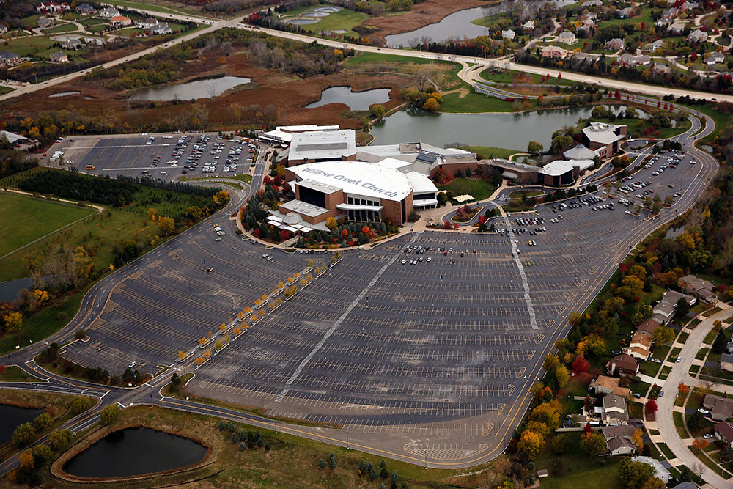Figure 3:* *Willow Creek: Bird’s Eye View*

The campus resembles a set of warehouses, or even a shopping mall—it is a far-cry from the Gothic cathedrals of the Middle Ages. The architecture of a church must communicate the church’s values while being “sensitive and adaptable to the context in which it resides” (Thumma). The Gothic cathedrals inspire—as they were meant to—a sense of awe, smallness, and reverence. As mentioned above, Goldberger notes this and compares this to the approach of megachurches, which “celebrate comfort, ease and the very idea of contemporary suburban life.” This context of comfortable suburban life is quite the opposite of medieval life under the shadow of poverty and bubonic plague. But it is the context of many modern Americans, and so the architecture of the nontraditional megachurch must mesh with this context. The sprawling, mall-like campus of Willow Creek accomplishes this. By rejecting traditional church architectural form, the church communicates a specific message: “religion is not a thing apart from everyday life” (Goldberger). Visitors driving up to the campus could mistake it for a community college. As a result, the only wonder a church like this may elicit from visitors is due to surprise at the fact it is actually a church (Goldberger).

This architectural connection to everyday life is continued within the church. The campus contains a large gym and atrium with tables and food counters (Goldberger), closely resembling a food court in the neighborhood mall. The center of church life, the worship center, is mega-sized like a cathedral, but familiar. Unlike the long, stone vertical lines of a cathedral, the worship center has a greater horizontal dimension (Figure 4). Rather than the wooden pews of a cathedral, or even a small Baptist church, the auditorium is filled with folding theater chairs. These chairs face a large stage illuminated with colored lights—ready to host the church’s large, theatrical Christmas and Easter programs. Of course, Dr. Thumma writes, the basic message of Christianity is taught; it is the packaging that is different at Willow Creek, and other “nontraditional” megachurches. And this is all to attract consumeristic baby boomers who have been turned off by “traditional” religion. The architecture of these churches serves as the first communicator to visitors of the everyday relevance of Christianity.

*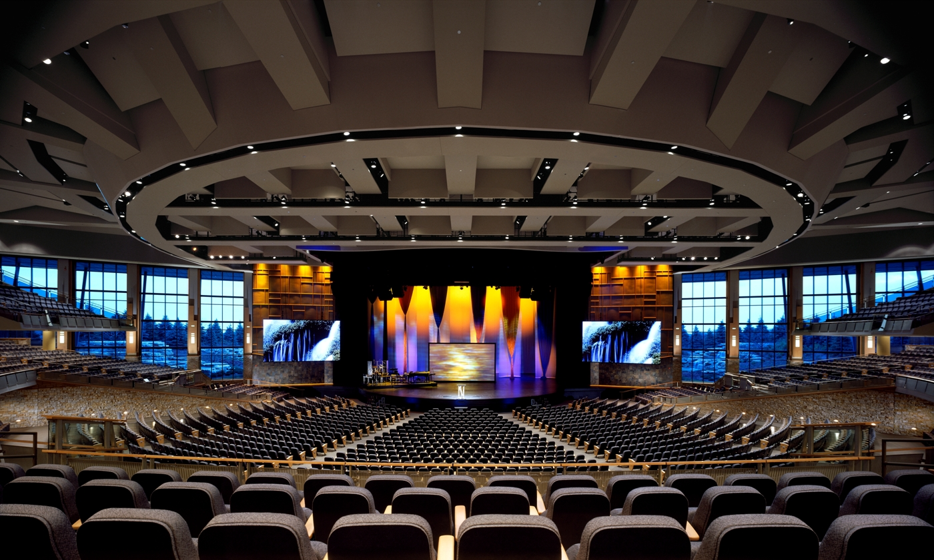Figure 4:* Hall *Main Auditorium*

Up to this point, the “functional objectives” of these two types of church architecture—the religious goals behind the design elements—have been explored in depth. Now a visual comparison will be given, using the Gothic cathedral of Santa Maria del Fiore in Florence, Italy, and Woodlands Church in The Woodlands, Texas.

The cathedral of Santa Maria del Fiore demonstrates the Gothic elements previously discussed. Figure 5 shows the pointed arches and ribbed vaulting of the church—the ribbed vaulting forms the ceiling in the center. The pointed arches are on either side, joining the ribbed ceiling to the columns. There are both vertical and horizontal lines in the architecture, but the vertical lines are longer and more pronounced. These serve as that “highway” for the eyes mentioned above—straight, unobstructed race-tracks. Since the observer is already at ground-level, the eyes have nowhere to go but up. Once the eyes have reached the ceiling, the sheer size of the space creates a sense of smallness and awe.

Figure 5: Malott Interior of Santa Maria del Fiore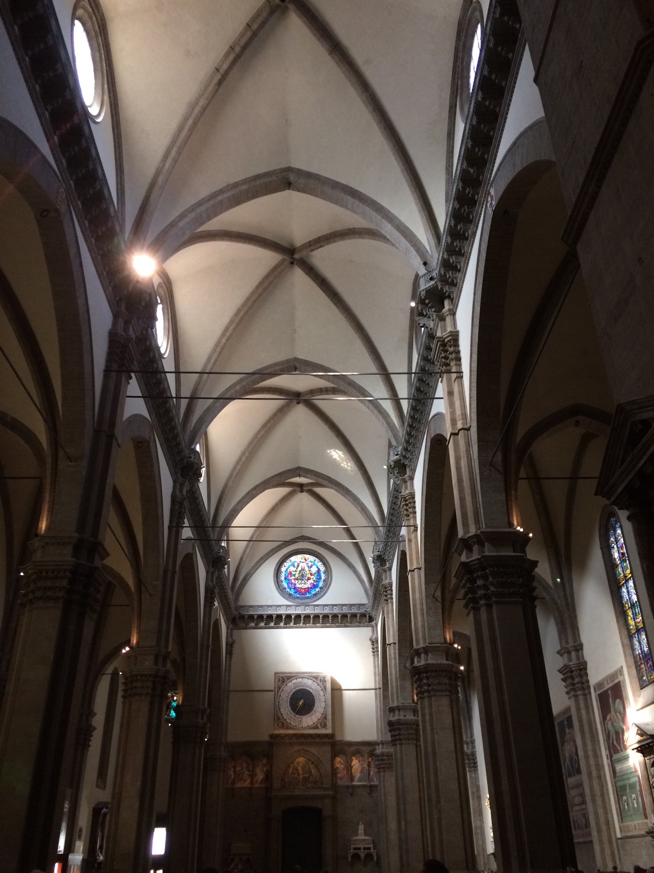

The stained-glass windows also enhance this sense of awe. Notice the location of most of the light in Figure 5—it is in the vaulted ceiling. This is yet another reason for the upward pull of the eyes. From there, the viewer’s gaze is drawn to the source of the light—the symbolic windows. Figure 6 shows the rose-shaped design of the window at the center of Figure 5 from the outside (top left of Figure 6). This window shows the virgin Mary at its center (this is hard to tell in the photo, due to the bright light coming through the window), visually communicating the importance of this figure. This “visual truth” for the illiterate is present at the entrance of the church, as well. Figure 7 shows the many sculptures surrounding the door, as well as a painting of Jesus and prominent figures of the faith on the tympanum (the surface between the door and the pointed arch).

Figure 6: Malott Facade and Bell Tower of Santa Maria del Fiore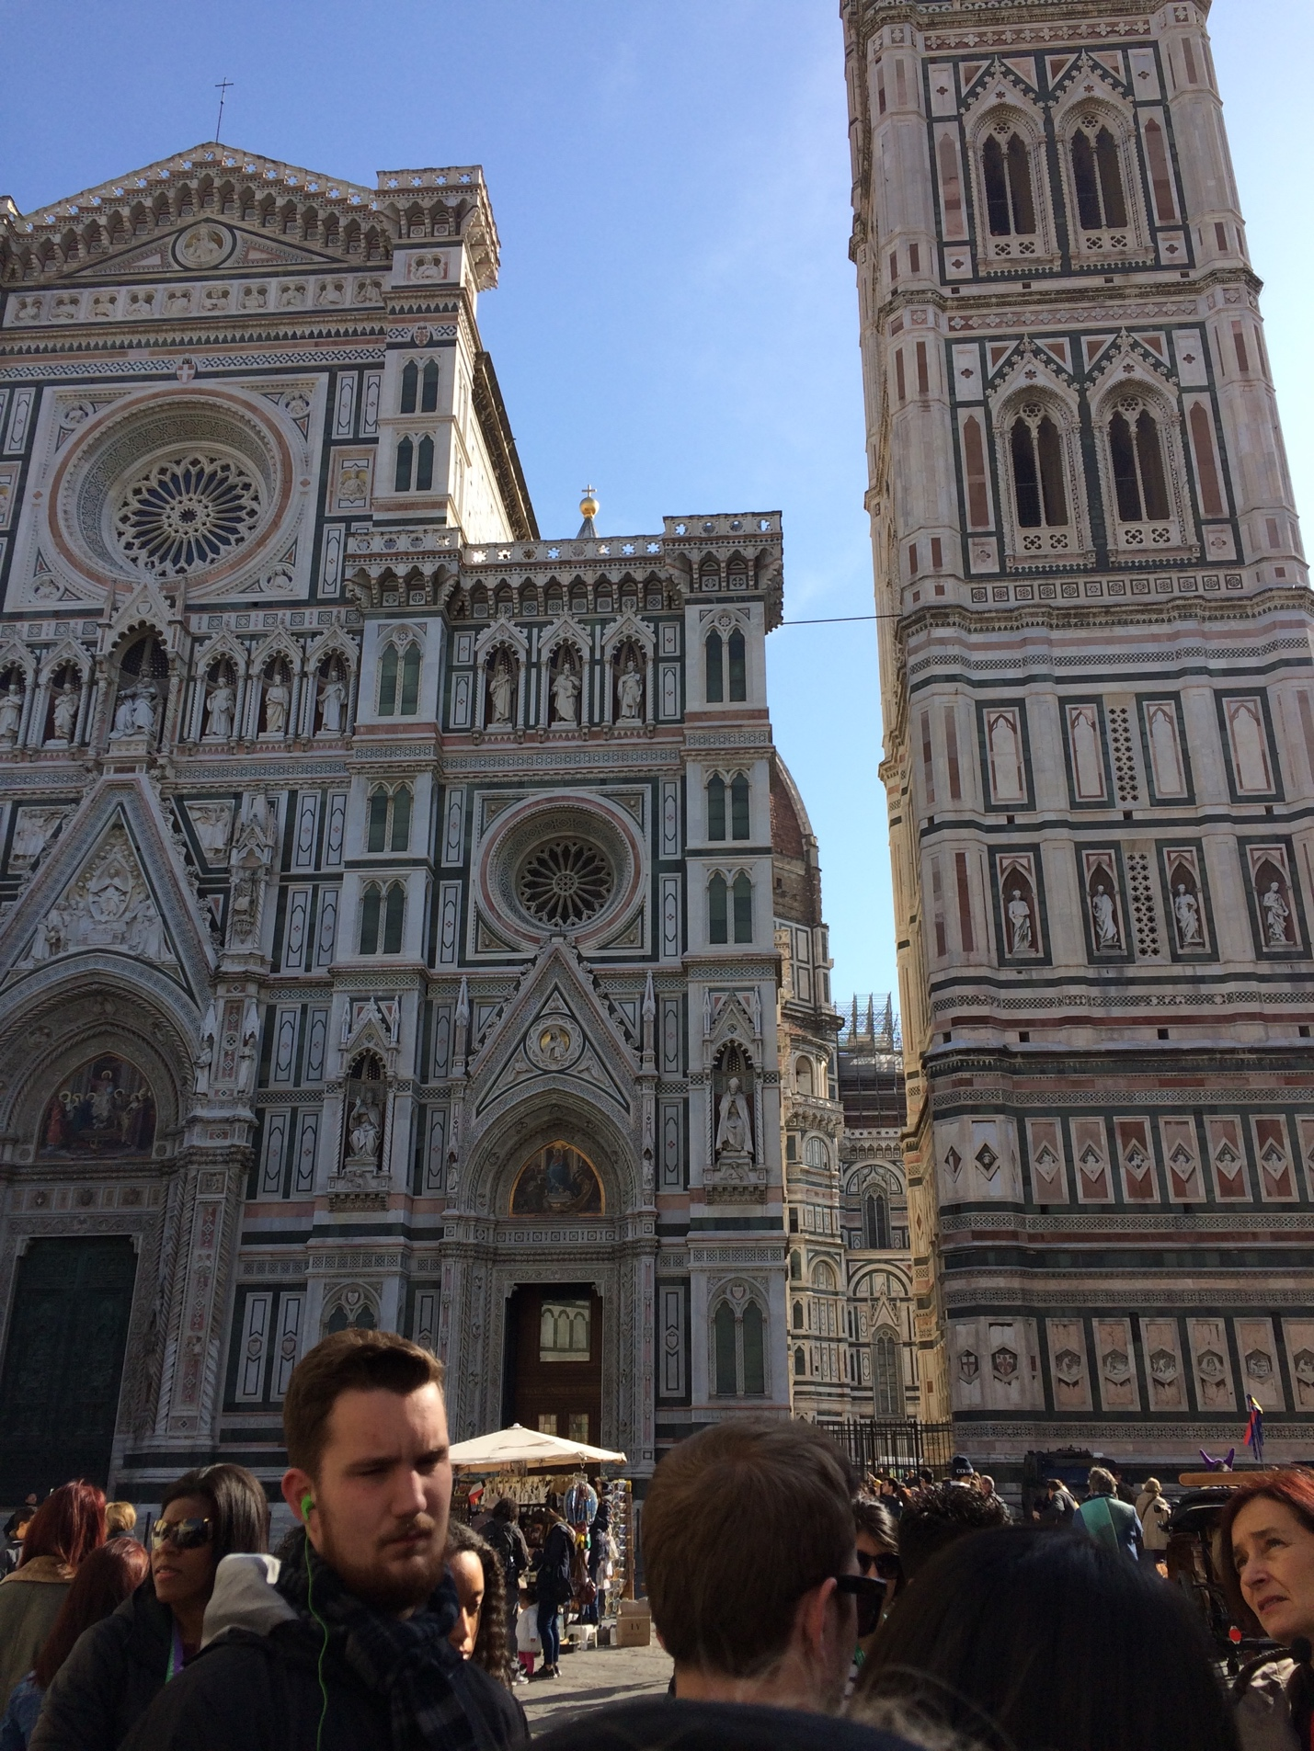

Figure 7: Malott Main Entrance of Santa Maria del Fiore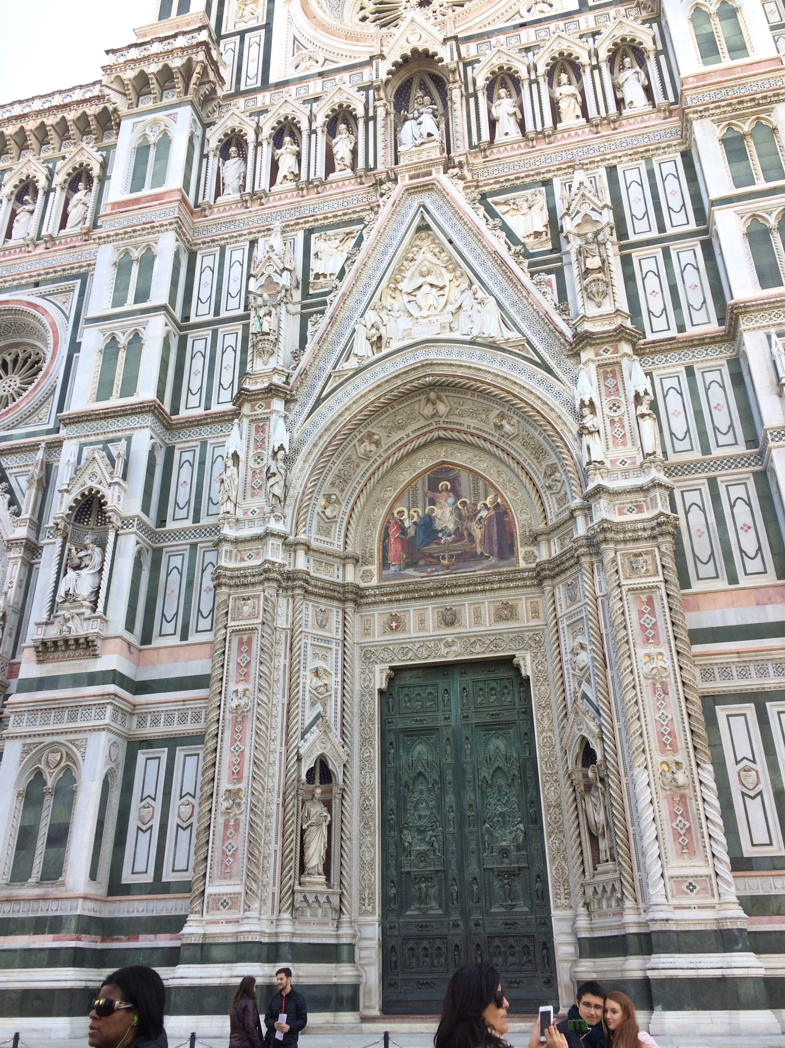

Woodlands Church demonstrates the contrasting architecture of the American megachurch. Its design does not mark it as a church—as Figure 8 shows, the entrance could easily be mistaken for the portal to a library on a college campus, a corporate office, or even a nice shopping mall. This is due to the modern architecture and lack of traditional symbolic features such a steeple or cross. The symbolically neutral exterior welcomes visitors who are looking for something relevant and nontraditional.

Figure 8: The Woodlands Church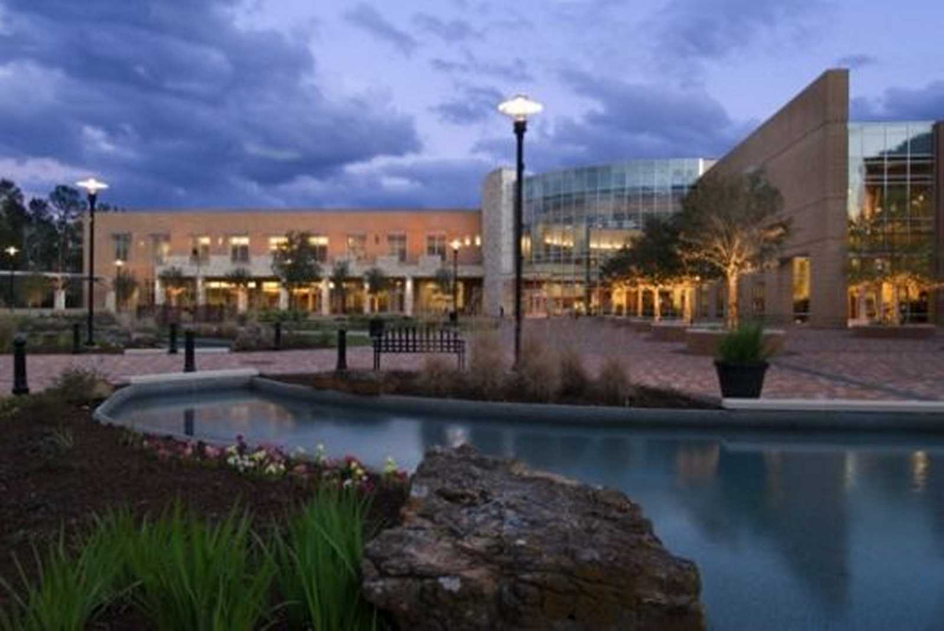

Inside, the same themes are continued. In the church’s café/bookstore area, a large space is made comfortable with familiar visual and ideological elements. Figure 9 shows this area, and the visual similarity it has to other community areas, like a mall or a coffee shop. Ideologically, this a place where consumers can acquire things for their needs, similar to a shopping center—coffee for a morning-revitalization and books for help with life and spiritual things—all in a hip, friendly neighborhood environment. Even here, inside the building, there is no symbolism. This trend is continued in the worship center (Figure 10). This is probably the largest space in the church, but it does not leave one feeling small and awed. As in the case of Willow Creek, the vertical lines that would draw the observer’s eyes upward give way to horizontal lines. But not only horizontal ones—the rows of seats are directed toward the focus point of the stage, along lines that radiate outward and upward. This achieves and overall effect of directing the viewers eyes down, away from the ceiling, to the stage. This avoids the awe-inspiring characteristic of cathedrals, while establishing yet another familiar yet fresh space—one similar to a concert venue or theater, but not to a traditional church.

Figure 9: Fellowship of the Woodlands – Café and Bookstore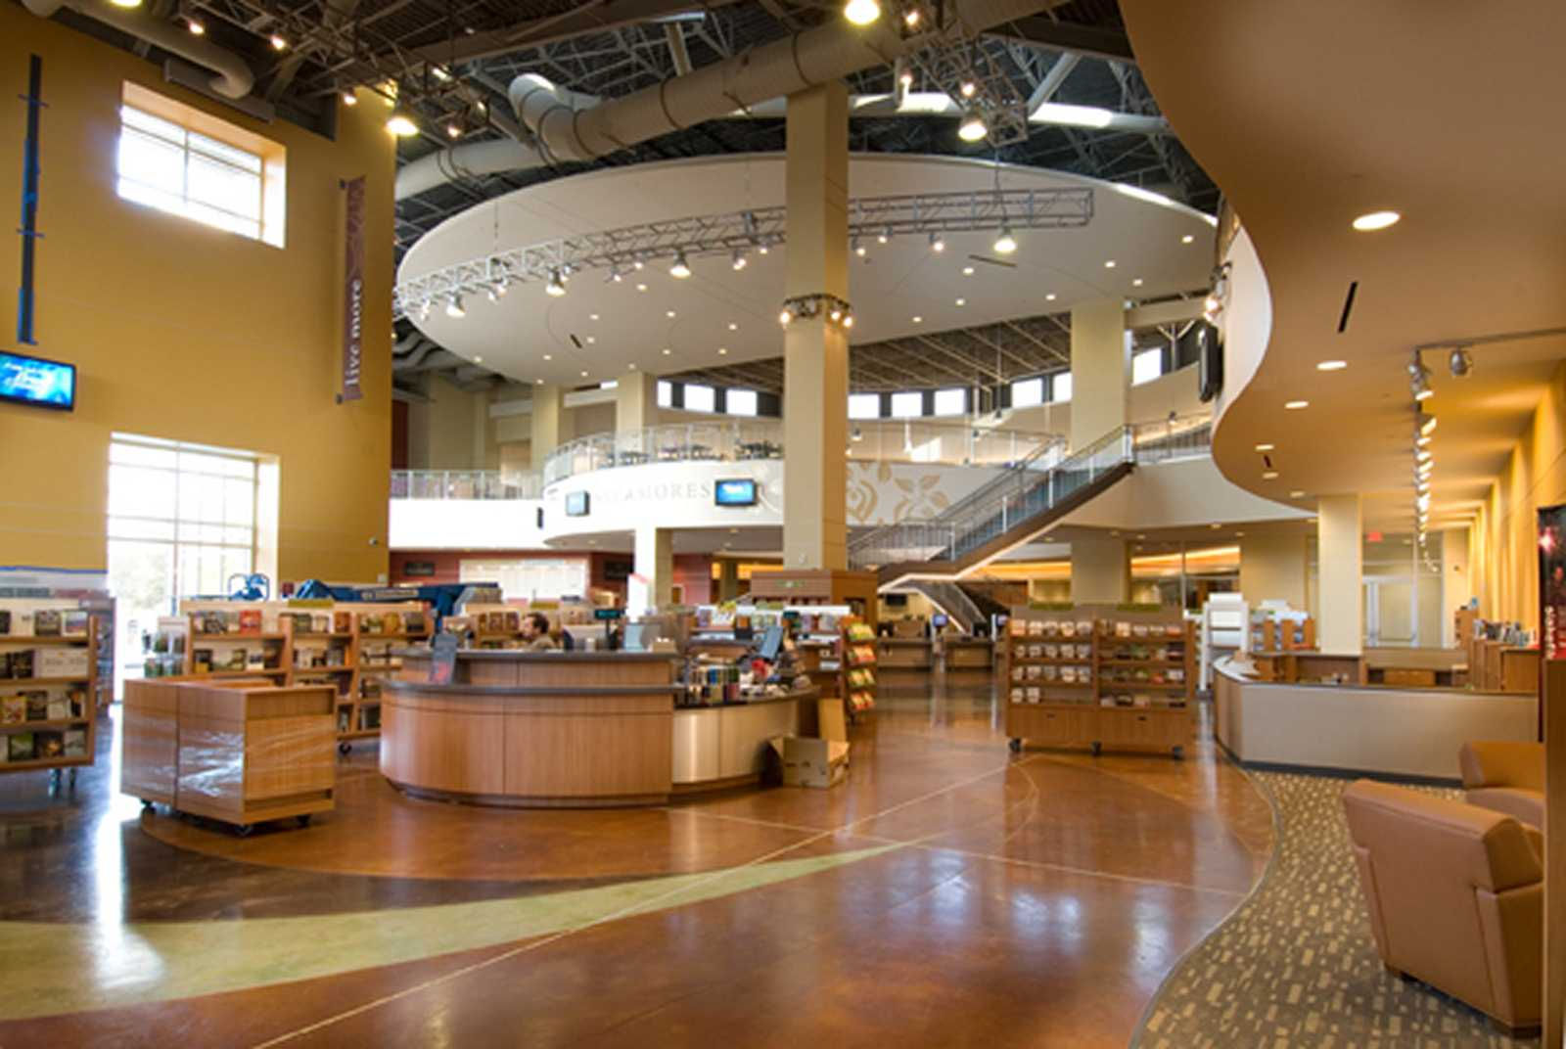

Figure 10: Auditorium of Woodlands Church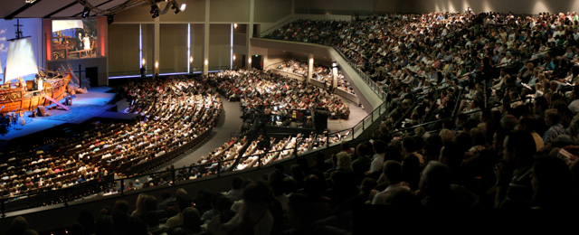

These elements communicate that the Christianity of Woodlands Church is modern, relevant to visitors’ needs, and not divorced from everyday life. This, in turn, offers comfort to a demographic composed of consumers seeking a new form of religion that is not the traditional Christianity they have been turned off by.

The functional objectives of the architecture of Gothic cathedrals and modern megachurches thus differ greatly. The cathedral is designed to evoke awe for God and remind of traditional biblical truths, while the megachurch is designed to invite the unchurched in through a comfortable, nontraditional, and familiar atmosphere. What do these functional differences reveal about the social context of each church?

As mentioned previously, the Gothic cathedral was born in France in the early twelfth century. At this time, Christianity was virtually the only religious option—more so the norm than just an option. “Christianity reigned over every aspect of medieval society” (Schlager and Lauer), and this was partly due to the medieval catholic church’s heavy involvement with the state. The propagation of the religion and construction of the cathedrals was not merely a private endeavor. These were public buildings designed to house the public religious activities, which were just as much functions of the state as they were of the church. Further, anyone able to pursue higher education went to the church for this—because the church was the educational institution of the time. As a result, no other religion was taught or explored. The Gothic cathedrals were built in a time when Christianity was *the* religion of society. There was no competition, so there was no need to “market” the religion to consumers.

Fast forward nine centuries to the social context of the American megachurch. The megachurch phenomenon has sprouted under a church culture that is not tied in with the government—the building of churches and the propagation of Christianity are private endeavors (at least insofar as they are not initiated by the government). As a result, Christianity is not enforced by the state, and there is freedom for the other religions that enter society via the melting pot nature of America. Further, higher education today is not exclusively administered within the context of the church—while there are Christian colleges, most universities today are secular. Today in America, Christianity is just one of many viewpoints and ways of life that aims to attract “spiritual shoppers.”

It is this change in social context that influences the different theological objectives in the architecture of Gothic cathedrals and modern American megachurches. The preceding discussion of these theological objectives, of the architectural elements that accomplish them, and two particular church buildings that exemplify them points to the fact that a church’s architecture is not an isolated creation. It is a product of social and theological influences. It is a rich display of complex factors that reach beyond the local church, both into the immediate social context, and a broader, historical root. The church buildings—whether awe-inspiring or comfortable and modern—that many individuals have walked in and out of on a weekly basis together serve as a window into the vast changes in the social context of the Christian church over the last nine centuries.

Works Cited

Abbot Suger. “Abbot Suger.” *Learn.Columbia.edu*, www.learn.columbia.edu/ma/htm/ms/ma_ms_gloss_abbot_sugar.htm. Accessed 4 May 2017.

*Auditorium of Woodlands Church.* Digital photograph, *Blog.WoodlandsChurch.tv,* Blog.woodlandschurch.tv/about/.Accessed 2 May 2017.

“Baby Boomers.” *History.com*, www.history.com/topics/baby-boomers. Accessed 4 April 2017.

Barnes, Stephen F. “Part I: Baby Boomers—Just Another Generation?” *SDSU.edu*, July 2007, calbooming.sdsu.edu/documents/PartIBabyBoomersAnotherGeneration.pdf.

Bratton, Susan. “The Megachurch in the Landscape: Adapting to Changing Sale and Managing Integrated Green Space in Texas and Oklahoma.” *Worldviews: Global Religions, Culture & Ecology*, vol. 16, no. 1, 2012, pp. 30-49, lscsproxy.lonestar.edu/login?url=http://search.ebscohost.com/login.aspx?direct=true&AuthType=ip,cpid&custid=s1088435&db=rlh&AN=71833666&site=ehost-live. Accessed 3 April 2017.

Chapuis, Julien. “Gothic Art.” *TheMetMusem.org*, Oct. 2002, Metmuseum.org/toah/hd/mgot/hd_mgot.htm.

Colby, Sandra L. “Talkin’ ‘Bout Our Generations: Baby Boomers and Millennials in the United States.” *Princeton.edu*, 2 May 2015, paa2015.princeton.edu/uploads/151342.

Dupre, Judith. *Churches.* HarperCollins, 2001.

*Fellowship of the Woodlands – Café and Bookstore.* Digital photograph, *StudioRedArchitects.com,* Studioredarchitects.com/woodlands-church-cafe-and-bookstore-the-woodlands-texas/. Accessed 2 May 2017.

Goldberger, Paul. “The Gospel of Church Architecture, Revised.” NYTimes.com, www.nytimes.com/1995/04/20/garden/the-gospel-of-church-architecture-revised.html. Accessed 20 Feb. 2017.

Hall, Steve. *Main Auditorium*. WillowProduction.org, www.willowproduction.org/venues/south-barrington/. Accessed 20 Feb. 2017.

Langham, Thomas C. “Seeker Churches (Book).” *Sociology of Religion*, vol 63, no. 2, 2002, pp. 260-261, lscsproxy.lonestar.edu/login?url=http://search.ebscohost.com/login.aspx?direct=true&AuthType=ip,cpid&custid=s1088435&db=rlh&AN=7180306&site=ehost-live.

Malott, Taylor. *Facade and Bell Tower of Santa Maria del Fiore.* 2017, digital photograph.

Malott, Taylor. *Interior of Santa Maria del Fiore.* 2017, digital photograph.

Malott, Taylor. *Main Entrance of Santa Maria del Fiore.* 2017, digital photograph.

Schlager, Neil, and Josh Lauer, editors. "The Gothic Cathedral: Height, Light, and Color." *Science and Its Times*, vol. 2, 2001. *World History in Context*, link.galegroup.com/apps/doc/CV2643450147/WHIC?u=san66643&xid=78165a43. Accessed 28 Apr. 2017.

Sidey, Kenneth H. “Boomer Boom and Bust.” *Christianity Today*, vol 37, no. 9, 1993, pp. 14-15, lscsproxy.lonestar.edu/login?url=http://search.ebscohost.com/login.aspx?direct=true&AuthType=ip,cpid&custid=s1088435&db=rlh&AN=9401114977&site=ehost-live.

*The Woodlands Church.* Digital photograph, *StudioRedArchitects.com,* Studioredarchitects.com/woodlands-church-the-woodlands-texas/. Accessed 2 May 2017.

Thumma, Scott. “Exploring the Megachurch Phenomena: Their characteristics and cultural context.” HartSem.edu, hirr.hartsem.edu/bookshelf/thumma_article2.html. Accessed 20 Feb. 2017.

TTaylor. *St Denis North a.* 2005, digital photograph, *Commons.Wikimedia.org*, Commons.wikimedia.org/wiki/File%3ASt_Denis_North_a.jpg.

Vellut, Guilhem. *Basilique de Saint-Denis @ Saint-Denis.* 31 Oct. 2016, digital photograph, *Commons.Wikimedia.org*, Commons.wikimedia.org/wiki/File%3ABasilique_de_Saint-Denis_%40_Saint-Denis_(30411922790).jpg.

*Willow Creek: Bird’s Eye View.* HaegerEngineering.com, www.haegerengineering.com/institutional. Accessed 20 Feb. 2017.